Objective: I will be able to graph the parent functions and analyze key features: Domain, Range, Intercepts, Symmetries, Maximum and Minimum given an interval.

Intercepts:
We will explore x and y intercepts for functions. They will always be written as ordered pairs!!
The ________________________ are the _______________________________________________ that cross the ____________________.

The ________________________ is the ______________________________________________ that crosses the ____________________.

Symmetries:
A function can have y-axis symmetry, origin symmetry or no symmetry.
Y-axis Symmetry:
Functions that have symmetry about the y-axis are called EVEN functions.
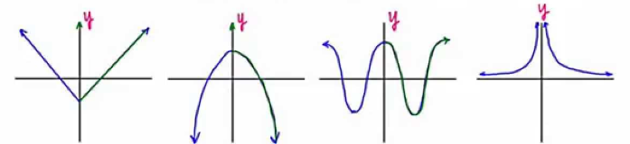
This means that if you were to ___________________ the graph along the ___________________, the two halves would _______________________________________.

Origin Symmetry:
Functions that have symmetry about the origin are called ODD functions.
This means that if you ________________________ the graph __________________ about the _____________________________, the graph will look _______________________________________________.
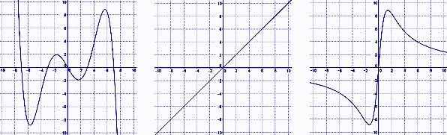

Extrema:
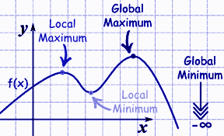
The extrema are the _____________________________ and ___________________________ values of a function.

Absolute or Global Maximum is the
________________ ______________________ point on the entire graph of a function.
Absolute or Global Minimum is the
________________ ______________________
point on the entire graph of a function.

Relative or local Extrema is a ___________________ on the graph where the function has a maximum or minimum value ___________________________ to the points in its immediate vicinity. In other words, the max and min within a specific______________________________.

Because these are points, they will be designated using _________________________________.

Example 1:
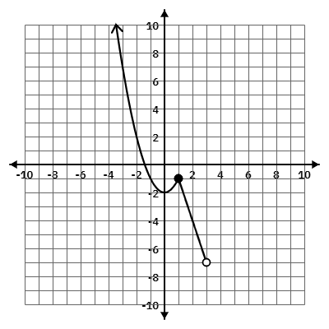
For the function below, provide all requested information.

X-intercept:

Y-intercept:

Relative Max for the interval [-3, 2]:

Relative Min for the interval [-3, 1]:

Type of Symmetry:

Domain in
Inequality:
Set:
Interval:

Range in
Inequality:
Set:
Interval:

